Specialist Outpatient Clinic waitlist audit
- Northern Health undertake regular waitlist audits for patients who have been waiting for an appointment for greater than 12 months.
- We conduct these audits to ask if you still require an appointment.
- We will send you a text message to your mobile number.
- If you are waiting for an appointment for more than one specialty you will receive separate text messages.
- The text message will be sent from ‘VicKey’ and will look like the image below. Clicking the link in the text message will take you to a portal which will ask you to enter your last name and date of birth to verify your identity. The portal will then ask you if you still need an appointment.
- If you have any difficulty completing the audit please contact us via the link below
https://forms.office.com/r/gnkGDm8qMH

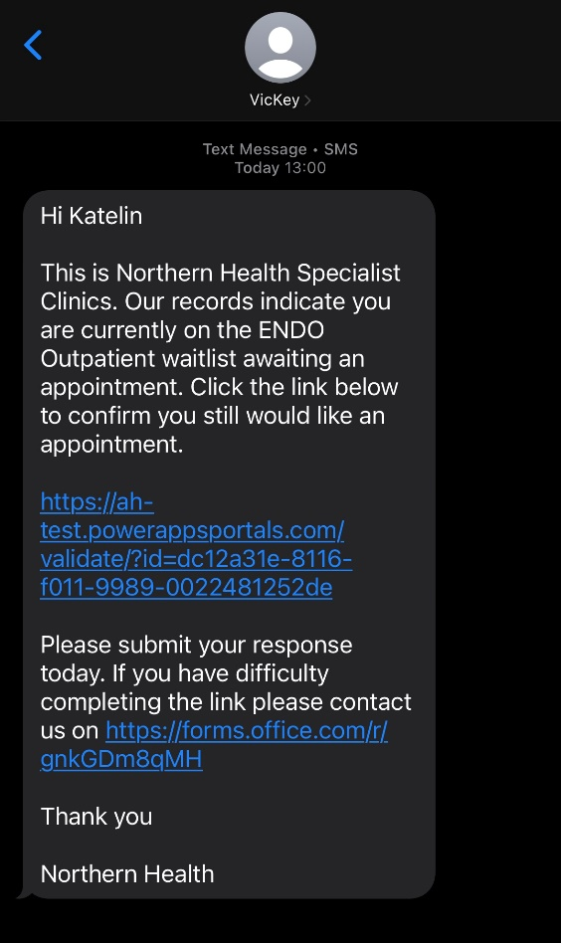

Specialist Outpatient Clinic planned appointment audit

- Northern Health undertake regular planned appointment audits for patients who have been waiting for an appointment for greater than 12 months.
- We conduct these audits to ask if you still require an appointment.
- These audits are conducted every 6 months as per Department of Health policy.
- We will send you a text message to your mobile number.
- If you are waiting for an appointment for more than one specialty you will receive separate text messages.
- The text message will look like the image below. Clicking the link in the text message will take you to a Microsoft form which will ask you to enter your full name, date of birth, address and phone number to verify your identity. The form will then ask you if you still require an appointment.

