Specialist Outpatient Clinic Appointments
- If your referral has been triaged as urgent we will contact you either via phone or text message to notify you of your appointment details. Your text message will be sent from ‘NorthrnHlth’ which will prompt you to access a link that contains your appointment letter.
- If your referral is triaged as routine you will be placed on our planned appointment waiting list. When an appointment is available you will be notified either via text message or letter.
- Please understand that wait times for outpatient appointments can vary and sometimes the wait time can be longer than expected as we continue to have a high demand for some services.
- If your condition gets worse before your appointment - please see your General Practitioner (GP). They may send a new referral to Specialist Outpatient Clinics which will be reviewed by a Northern Health clinician to see if an earlier appointment is required.
- Most clinics send a text message reminder to your mobile phone one week before your appointment and another one two days before your appointment.
- Northern Health Specialist Outpatient Clinics provide appointments in person, by video and by telephone. Your clinician will determine the most appropriate appointment mode for your upcoming appointment.
Appointment types
Face to face
- If your appointment is ‘face to face’ you need to attend the hospital specified in the text message/ appointment letter.
- Please do not attend your outpatient appointment if you have any of the following symptoms: flu or COVID-19 like symptoms, such as fever, cough, sore throat, sudden onset of vomiting and diarrhoea, or generalised unexplained rash.
- You should contact Specialist Outpatient Clinics to either change from a face to face appointment to video or telephone appointment or reschedule your clinic appointment.
Telephone
- If your appointment is ‘telephone’ your clinician will call you:
between 8.30am and 12.30pm for a morning appointment,
or between 1pm and 5pm for an afternoon appointment.
- Please note, when you receive the call, the number may not be displayed and appear as ‘unknown number.’ If you miss our call/s, contact the number on your appointment letter/text message to reschedule.
Telehealth
- If your appointment is ‘telehealth’ please click on the link in the text message to connect for your video call.
For paediatric patients, the primary caregiver (parent or legal guardian only) must attend the appointment.

Specialist Outpatient Clinic Locations:
For transport options to get to your appointment please click on the site links below.
- Northern Hospital Epping – 185 Cooper Street, Epping
- Broadmeadows Hospital – 35 Johnstone Street, Broadmeadows
- Craigieburn Centre – 274 Craigieburn Road West, Craigieburn
- Kilmore District Hospital – 1 Anderson Road, Kilmore
- Epping Private Hospital and Medical Centre – 230 Cooper Street, Epping

What to bring to your appointment?
- your appointment text message or letter/s
- any relevant X-ray films, scans, ultrasounds, laboratory or any other test results or reports
- list of medicines you are currently taking (or the boxes), including medicines you have bought without a prescription, such as herbal supplements and vitamins
- adverse drug alert card (if you have one)
- any aids you may require (glasses, hearing aids, walking stick or frame etc)
- Medicare card or veterans’ card
- Health Care Card and/or concession card (if you have one)
- TAC or WorkCover claim number (if relevant)
- any additional requests listed on your letter
- a list of any questions you want to ask the specialist

When you arrive at your appointment:
Self-service kiosks are located throughout Specialist Clinics to check-in for your appointment.
To check-in, follow these steps:
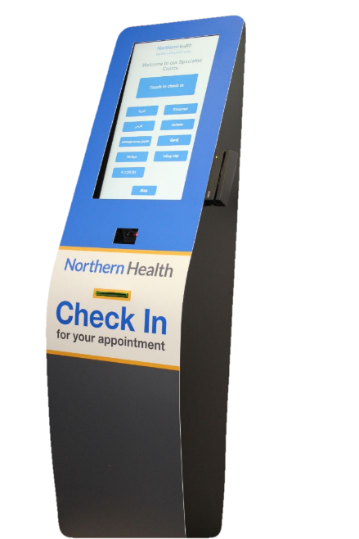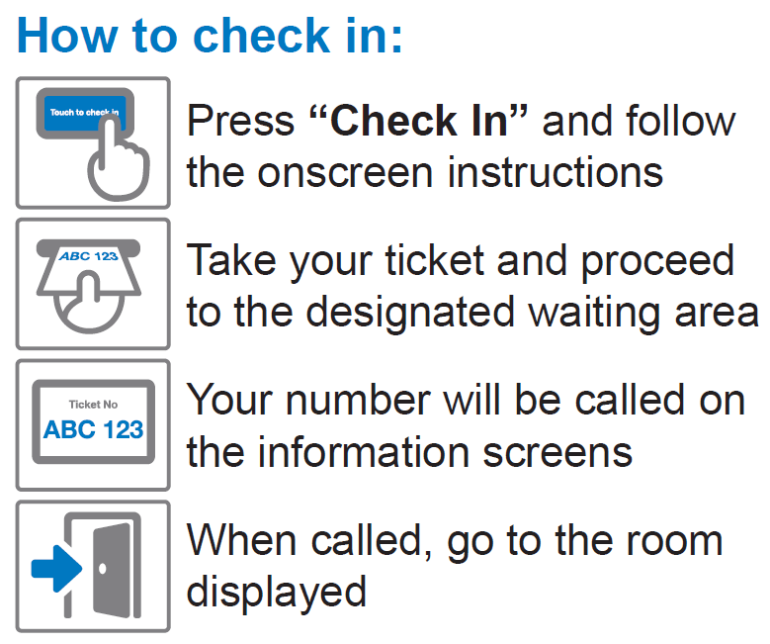

Interpreter Service
If you require an interpreter for your appointment, please ask your GP to clearly note this on your referral. For more information about interpreter services – click here.

Northern Hospital Epping
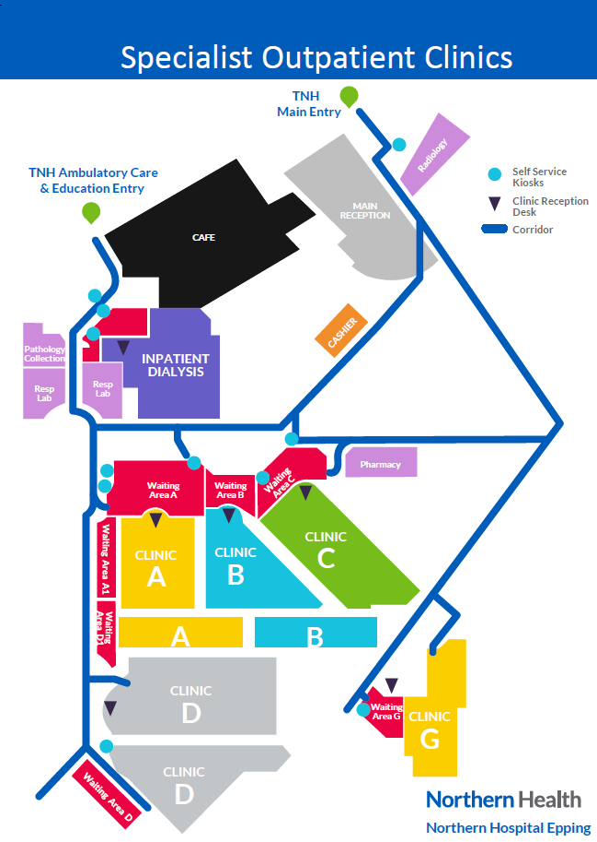

Broadmeadows Hospital
