Contents
Referrals to Specialist Outpatient Clinics 1
Referral and Appointment Enquiries 1
Freedom of Information Enquiries 1
Specialty clinics provided by Northern Health 2
HealthLink SmartForms Information 2
Attaching results & reports to HealthLink SmartForms 3
HealthLink SmartForms Enquiries 4
eReferral Support Contact Information 5
Statewide Referral Criteria 5
HealthPathways Melbourne 5
Specialist Outpatient Clinic contact details 5

Referrals to Specialist Outpatient Clinics
Northern Health recommends HealthLink SmartForms to send referrals to Northern Health, including investigation results and reports.
HealthLink is a secure, safe electronic channel for delivery of identifiable clinical information between healthcare providers.

Referral and Appointment Enquiries
For submitted referral enquiries or appointment enquiries, please click here - Specialist Outpatient Clinic Enquiries

Freedom of Information Enquiries
For all Freedom of Information enquiries please contact (03) 8405 8258. Or send an email to foi@nh.org.au
For further information please click here

Specialty clinics provided by Northern Health
Allergy | Neurology & Stroke
Antenatal | Oncology
Breast Surgery | Ophthalmology
Cardiology | Orthopaedic
Colorectal Surgery | Orthopaedic Spinal
Dermatology | Paediatric Allergy
Endocrinology | Paediatric Medicine
Ear, Nose and Throat | Paediatric Surgery
Endocrine Surgery | Plastic Surgery
Fracture | Renal/Nephrology
Gastroenterology | Respiratory
General Medicine | Rheumatology
General Surgery | Sleep Medicine
Gynaecology | Sports Medicine
Haematology | Thoracic Surgery
Hepato Pacreato Biliary Surgery | Upper GI Surgery
Immunology | Urogynaecology
Infectious Diseases | Urology
Long COVID | Vascular
Lung Mass

Please note for referrals to the Orthopaedic Spinal service it is mandatory to complete the Spinal Assessment Form (BAMS form) click here to access form
Please note for referrals to Respiratory for a Lung Function Test please complete a Lung Function Test Referral Form click here to access form

HealthLink SmartForms Information
For HealthLink information relating to Practice Management Software, please see below:
Medical Director | Best Practice | Genie
Quick Start Guide Medical Director | Quick Start Guide Best Practice | Quick Start Guide Genie
Tutorial Video Medical Director | Tutorial Video  Best Practice | Tutorial Video  Genie
MedTech Evolution | Zedmed | My HealthLink Portal
Send via My HealthLink Portal | Send via My HealthLink Portal | Tutorial Video  MyHealthlink Portal
Tutorial Video  MyHealthlink Portal | Tutorial Video  MyHealthlink Portal

Practices without conformant software can register for a ‘free’ HealthLink Portal licence by completing the online registration form – click here for HealthLink application form
When completing the HealthLink application form click the ‘No/Other’ tick box and document in the ‘If other please specify’ that you would like to use HealthLink SmartForms.
Click two checkboxes - Receive Electronic Correspondence and SmartForm eReferrals.
Once HealthLink receives your completed application, they will forward the portal details to you.
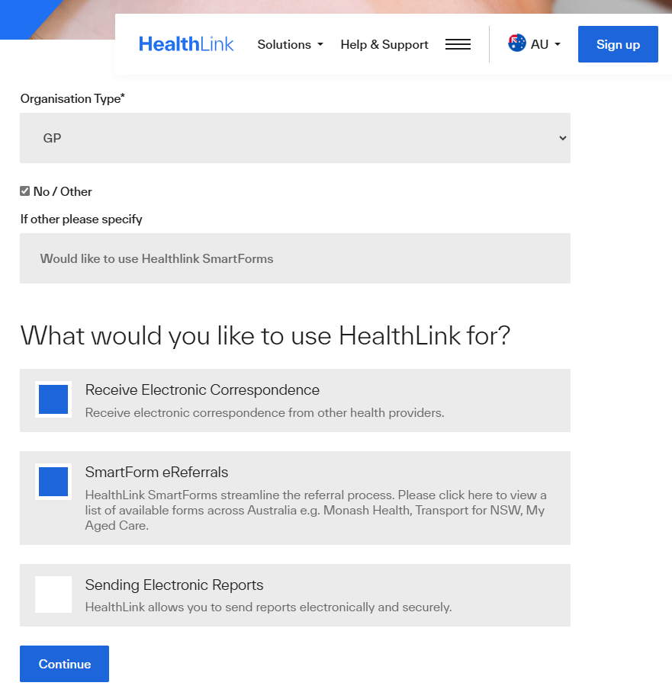

Attaching results & reports to HealthLink SmartForms
- Attaching files from Clinical Information System (CIS) support: gif, html, jpeg, doc, docx,pdf, txt, rft and tiff.
- Attaching file from computer (desktop) supports files that end in types: doc, docx, gif, htm, html, jpeg, jpg, pdf, rtf, tif, tiff and text.
For Best Practice and Medical Director users, please ensure all plain text investigation includes the header.

Include Header in Best Practice:
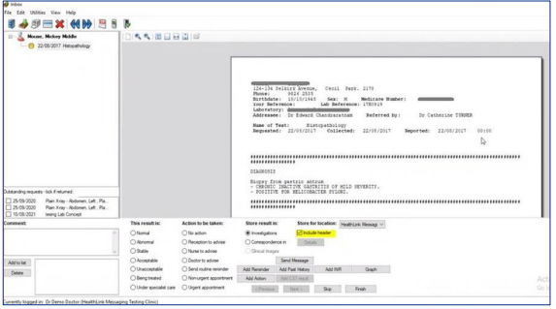
Include/Exclude Header in Medical Director (via Tools -> Options -> Investigations): 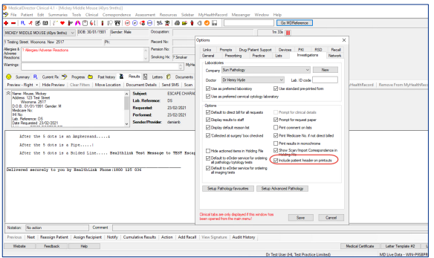
If you are unable to attach results and reports please contact HealthLink on 1800 125 036 or email HelpdeskHL@healthlink.net for assistance.

HealthLink SmartForms Enquiries
For enquiries directly relating to the HealthLink SmartForms, please contact HealthLink on 1800 125 036 or HelpdeskHL@healthlink.net.

eReferral Support Contact Information
If you would like assistance in enabling HealthLink for your practice or would like additional training, including demonstration, please contact your local Primary Health Network (PHN):
North Western Melbourne
Eastern Melbourne
Find other local PHNs

Statewide Referral Criteria
Northern Health follow referral acceptance criteria based upon Statewide Referral Criteria for a number of health conditions across a number of specialties.
For more information on the minimum requirements for referral to each specialty for specific conditions, please visit https://src.health.vic.gov.au/specialities
HealthLink SmartForms have been developed for a number of Statewide Referral Criteria to help GPs meet the requirements of the Statewide Referral Criteria.
If a referral does not contain the minimum required content it will be declined with written notification to the referring health professional and patient.

HealthPathways Melbourne
HealthPathways Melbourne provides referring GPs with a comprehensive suite of clinical pathways, including guidance on when to refer and required information to accompany a referral. https://melbourne.communityhealthpathways.org
For access to HealthPathways Melbourne please contact info@healthpathwaysmelbourne.org.au

Specialist Outpatient Clinic contact details
Northern Health Specialist Clinics
8405 8335
Specialist Outpatient Clinic Enquiries

