Your authority must be signed, dated and all relevant details completed for the application to be processed.

New Employee ☐ Car Park ☐ Identification ☐ Building Security ☐ Bike Cage ☐Reactivate ☐ Replacement ☐

Do you have a pacemaker: ☐ Yes ☐ No

Note: Lost or Damaged cards will incur a $20.00 replacement cost. This is payable via Cashiers, Engineering or via cost centre with Managers approval. *** AP Receipt attached ☐ or Cost Centre

Personal Details:

Surname : First Name:

Preferred Name: Employee No:

Position: Department:

If EEN select medication endorsement: Organisation or

Oral ☐Topical ☐ S/C ☐ IM ☐IV ☐ University:
Computer Logon

Telephone: Username:

Campus: Campus
Access: NHE ☐ NCHER ☐ BH ☐ BC ☐ CC ☐

Managers Name: Managers Signature:

Staff Car Park Access Request (Please see overleaf for details):
Campus Parking Access Required: | ☐ NHE | ☐ BC Permit |  |  |  | ☐ BH | ☐ CC
Payment Method Selected:
☐ Pre-Tax Payroll Deduction [$56.00 Per Fortnight] OR |  |  | ☐ Pay As You Go Manual Recharge [$6.25 Per Day]
Effective Date: / /
Vehicle Details (maximum two per staff member):

Make & Model: |  |  |  | Registration:
Make & Model: |  |  |  | Registration:
Authorisation For Payroll Deduction:
I hereby authorise the payroll deduction for car parking access from my salary/wages. Car parking fees are $56.00 per fortnight (fees may change without notice according to Health Service policy). Deductions may be cancelled for periods of leave of 2 weeks or more by completing a Cease Car Parking Deductions form.
Signature: |  |  |  |  | Date: / /
OFFICE USE ONLY:
Identification Card No.:
(Back of card)
 | HR Signature |  |  | Date: / / | HR Operations |  |  | Date: / /
 | FM Signature |  |  | Date: / / | Security |  |  | Date: / /
 | Point Parking Signature Date: / / |  |  |  |  |  |  |  |  |  | Date: / /
HOW TO PAY: (Rates are subject to change without notice)

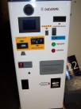 | Pay As You Go Manual Recharge (The Northern Hospital & Craigieburn Health Service)  Casual Daily Rate: $6.25 Per Day  Staff members can top up their own card by Pay As You Go Manual recharge at any of the auto pay machines located around the campus. It is the responsibility of the employee to ensure there is sufficient funds on the card otherwise you will not be able to exit the car park until funds are deposited. An Identification Security Car Parking Request form will need to be completed. Forms can be obtained from the Northern Health Intranet Site or administrative areas at all Northern Health campuses. If you have any queries please contact Support Services on 8405 8338
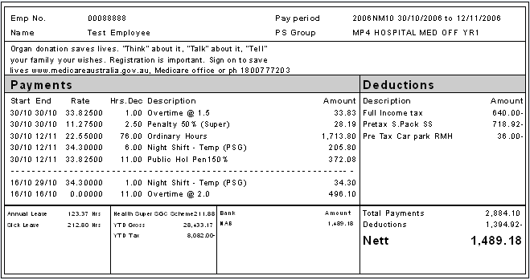 | Pre-Tax Payroll Deduction  Fixed Permanent Rate: $56.00 Per Fortnight  Staff members can have a fixed fortnightly rate deducted from their salary on a fortnightly basis pre-tax. This allows 24/7 access to staff parking at nominated campuses. An Identification Security Car Parking Request form will need to be completed. Forms can be obtained from the Northern Health Intranet Site or administrative areas at all Northern Health campuses. A cease deduction form must be completed if you go on rotation or on leave for more than 2 weeks (4 weeks’ notice is required). This will cease all payments from your salary whilst away. On return you will need to reactivate card to start deduction again if you have any queries please contact Human Resources on 8405 8034.
Bike Cage (The Northern Hospital only)

The Northern Hospital has a bike cage located at the rear of the hospital. Staff can park their pushbikes free of charge. All that is required is an access card to enter the cage. All employees requesting access to the cage need to complete an Identification Security Car Parking Request form. Further enquiries please contact Human Resources 8405 8034.

 | Staff wishing to park on site have two options:  - Pay As You Go Manual Recharge  Cards can be topped up at the auto pay stations across the site, using cash or credit card  There are 4 x Auto pay stations located at TNH:  - 2 x Public car park  - 1 x Outpatient Clinic D – Entrance  - 1 x Corridor opposite Environmental Services  - Pre-Tax Payroll Deduction
 | Staff wishing to park on site have two options:  - Pre-Tax Payroll Deduction. A parking permit sticker will be provided and must be displayed.  - Paid parking is available on site, Tickets should be purchased at the pay station located in the staff car park and displayed on your dashboard:  Rates: $5.00 0 – 2 hours  $9.00 2 – 4 hours  $11.00 greater than 4 hours
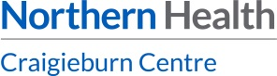 | Staff wishing to park on site have two options:  - Pre-Tax Payroll Deduction.  - Pay As You Go Manual Recharge  Cards can be topped up at the auto pay stations across the site, using cash or credit card
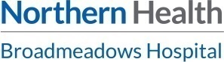 | Staff wishing to park on site have two options:  - Pre-Tax Payroll Deduction. Administration staff at BHS will be able to assist you: Mon – Fri: 8:30pm – 5:00pm.  2. Pay As You Go Manual Recharge  Cards can be topped up at the auto pay stations across the site, using cash or credit card
Give us a call | Northern Health is pleased to help you if you have any concerns about your car parking/security access services. Please call us on:  Security Access – Engineering Department 8405 8475  Car Parking Access – Point Parking 8405 2508  Human Resources – 8405 8034  *Important Information  If you are an intern and leave to go on rotation please ensure that you signed a cease deductions form and return to Human Resources before leaving.

